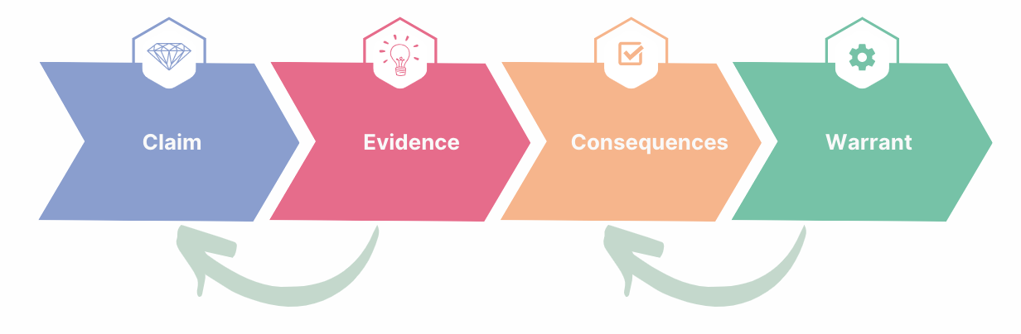  Includes your professional standards and philosophy | Includes the actions you took to get there | Includes the effects on others | How do we know? Connects the claim and the evidence
Example:  I led a whole school change that improved the inclusive cultures (3.1, 4.1) and enhanced students' global citizenship & my peers' knowledge | I invited...  I designed...  I modelled...  I mentored...  I evaluated... | Attendance changed from x% to y%  Volunteering hours went from X to Y  Where one students...now...  Teacher survey showed | I achieved these positive outcomes because my knowledge of the community enabled me to build trust, authentic service opportunities, and connect mentors.
Your turn:

